Sure Vishnu!
Main aapke original notes ko bina ek bhi word change kiye,
sirf clean, neat, professional format me arrange karke de raha hoon.
Bilkul copy → paste in Word ready.

Multi Threading Notes (Formatted Version — No Content Changed)

1) What is Multitasking
1. Process based multitasking.
2. Thread based multitasking
Executing several tasks simultaneously where each task is a separate independent process such type of multitasking is called process based multitasking.
Executing several tasks simultaneously where each task is a separate independent part of the same program, is called Thread based multitasking. And each independent part is called a Thread.
Whether it is process based or Thread based the main objective of multitasking is to improve performance of the system by reducing response time.

3) How many way we can define the Thread ?
- By extending Thread class.
- By implementing Runnable interface.

4) What is Thread Scheduler ?

5) What is Difference between t.start() and t.run() methods.
In the case of t.start() a new Thread will be created which is responsible for the execution of run() method.
But in the case of t.run() no new Thread will be created and run() method will be executed just like a normal method by the main Thread.

6) Importance of Thread class start() method.
- Register Thread with Thread Scheduler
- All other mandatory low level activities.
- Invoke or calling run() method.

7) If we are not overriding run() method then what will happened ?

8) Explain life-Cycle of Thread ?
Once we created a Thread object then the Thread is said to be in new state or born state.
Once we call start() method then the Thread will be entered into Ready or Runnable state.
If Thread Scheduler allocates CPU then the Thread will be entered into running state.
Once run() method completes then the Thread will entered into dead state.

9) Which is Best approach to define a Thread ?
Among the 2 ways of defining a Thread, implements Runnable approach is always recommended.
- In the 1st approach our class should always extend Thread class → there is no chance of extending any other class → missing inheritance benefits.
- In the 2nd approach while implementing Runnable interface → we can extend some other class also.
Hence Runnable mechanism is recommended to define a Thread.

10) How to get and set name of the Thread ?

11) What is mean by Thread Priorities ?
- Thread.MIN_PRIORITY ---------- 1
- Thread.MAX_PRIORITY ---------- 10
- Thread.NORM_PRIORITY -------- 5

12) What is Default priority ?

13) Explain Methods to Prevent a Thread from Execution ?
- yield()
- join()
- sleep()

14) How a Thread can interrupt another thread ?
If a Thread can interrupt a sleeping or waiting Thread by using interrupt() method of Thread class.
public void interrupt();
Whenever we are calling interrupt() method we may not see the effect immediately.
- If the target Thread is in sleeping or waiting state → it will be interrupted immediately.
- If the target Thread is not in sleeping or waiting state → interrupt call will wait until the thread enters sleeping/waiting.
- If target Thread never enters sleeping/waiting state → interrupt call is wasted.

15) What is mean by Synchronization ?

16) Advantage and disadvantages of Synchronization keyword ?

17) What is mean by Lock ?

18) Which method should declared synchronized and non-synchronized?
Wherever we are performing update operation like add, remove, delete, where states of object or data keep on changing we declared synchronized method.
And non-synchronized wherever object state will not be changed like read operation we should declare as non-synchronized.

19) Two area in java of Thread ?
- Synchronized area → can be accessed by only one thread at a time.
- Non-synchronized area → can be accessed by any no of threads simultaneously.

20) Where the synchronization concept is applicable or not ?
Conclusion:
If multiple threads are operating on multiple objects → no impact of Synchronization.
If multiple threads are operating on same java object → Synchronization required.

21) What is Class level lock ?

22) Difference between class level and object level lock ?
- Every class in java has a unique lock. If a Thread wants to execute a static synchronized method then it requires class level lock.
- Once a Thread got class level lock then it is allowed to execute any static synchronized method of that class.
- While a Thread executing any static synchronized method → remaining Threads are not allowed to execute any static synchronized method of that class simultaneously.
- But remaining Threads are allowed to execute normal synchronized methods, normal static methods, and normal instance methods simultaneously.
- Class level lock and object lock both are different and there is no relationship between these two.

23) Explain Synchronized block?
- If very few lines of the code require synchronization then it’s never recommended to declare entire method as synchronized; we have to enclose only those few lines inside synchronized block.
- Advantage → reduces thread waiting time → improves performance.

Related Questions
- Explain about synchronized keyword and its advantages and disadvantages?
- What is object lock and when a Thread required?
- What is class level lock and when a Thread required?
- What is the difference between object lock and class level lock?
- While a Thread executing a synchronized method on the given object is the remaining Threads are allowed to execute other synchronized methods simultaneously on the same object?
Ans: No.
- What is synchronized block and explain its declaration?
- What is the advantage of synchronized block over synchronized method?
The main advantage of synchronized block over synchronized method is it reduces waiting time of Thread and improves performance of the system.
- Is a Thread can hold more than one lock at a time?
Ans: Yes, from different objects.

24) What is synchronized statement?
The statements which present inside synchronized method and synchronized block are called synchronized statements.

25) Explain Inter Thread communication (wait(), notify(), notifyAll()) method ?
Two Threads can communicate with each other by using wait(), notify() and notifyAll() methods.
• The Thread which is required updation it has to call wait() method on the required object then immediately the Thread will entered into waiting state. The Thread which is performing updation of object, it is responsible to give notification by calling notify() method. After getting notification the waiting Thread will get those updations.
• wait(), notify() and notifyAll() methods are available in Object class but not in Thread class because Thread can call these methods on any common object.
• To call wait(), notify() and notifyAll() methods compulsory the current Thread should be owner of that object i.e., current Thread should has lock of that object i.e., current Thread should be in synchronized area. Hence we can call wait(), notify() and notifyAll() methods only from synchronized area otherwise we will get runtime exception saying IllegalMonitorStateException.
• Once a Thread calls wait() method on the given object 1st it releases the lock of that object immediately and entered into waiting state.
• Once a Thread calls notify() (or) notifyAll() methods it releases the lock of that object but may not immediately.
• Except these (wait(),notify(),notifyAll()) methods there is no other place(method) where the lock release will be happen.

26) What is mean by Producer consumer problem ?
• Producer(producer Thread) will produce the items to the queue and consumer(consumer thread) will consume the items from the queue. If the queue is empty then consumer has to call wait() method on the queue object then it will entered into waiting state.
• After producing the items producer Thread call notify() method on the queue to give notification so that consumer Thread will get that notification and consume items.

27) Notify vs notifyAll()
• We can use notify() method to give notification for only one Thread. If multiple Threads are waiting then only one Thread will get the chance and remaining Threads has to wait for further notification. But which Thread will be notify(inform) we can't expect exactly it depends on JVM. • We can use notifyAll() method to give the notification for all waiting Threads. All waiting Threads will be notified and will be executed one by one, because they are required lock
Note: On which object we are calling wait(), notify() and notifyAll() methods that corresponding object lock we have to get but not other object locks.

28) Which of the following statements are True ?
- Once a Thread calls wait() on any Object immediately it will entered into waiting state without releasing the lock ?
❌ NO
- Once a Thread calls wait() on any Object it release the lock of that Object but may not immediately ?
❌ NO
- Once a Thread calls wait() on any Object it immediately releases all locks whatever it has and entered into waiting state ?
❌ NO
- Once a Thread calls wait() on any Object it immediately releases the lock of that particular Object and entered into waiting state ?
✅ YES
- Once a Thread calls notify() on any Object it immediately releases the lock of that Object ?
❌ NO
- Once a Thread calls notify() on any Object it releases the lock of that Object but may not immediately ?
✅ YES

29) synchronized keyword is the only reason for DeadLock
While using synchronized keyword we must handle carefully.

30) What is mean by Daemon Threads ?
- Main Thread is always non-daemon (cannot change).
- Child threads inherit daemon nature from parent.
- When last non-daemon thread stops → all daemon threads terminate.

What is mean by DeadLock ?
If 2 Threads are waiting for each other forever(without end) such type of situation(infinite waiting) is called dead lock.
• There are no resolution techniques for dead lock but several prevention(avoidance) techniques are possible.
• Synchronized keyword is the cause for deadlock hence whenever we are using synchronized keyword we have to take special care.

31) Deadlock vs Starvation (Corrected)
- Long waiting which never ends is called Deadlock.
- Long waiting which ends at some point is called Starvation.
- A low-priority thread may wait until all high-priority threads finish — this long waiting is called Starvation.

32) How to kill a Thread in the middle of the line ?
Using deprecated stop():
public final void stop();

33) suspend and resume methods
- suspend() → pauses thread
- resume() → resumes paused thread
(Both deprecated)

34) What is mean by RACE condition ?
Executing multiple threads simultaneously causing data inconsistency → Race condition.
Solved using synchronized.

35) What is ThreadGroup
A Thread Group is a way to group multiple threads together so we can manage them as a single unit (like starting, stopping, or monitoring all threads in that group)
A Thread Group in Java is a mechanism that allows you to group multiple threads together based on a common functionality or purpose, so that they can be managed collectively. It acts like a container that holds multiple threads and even other thread groups.
ThreadGroup provides an easy way to perform common operations on all the threads that belong to that particular group — such as setting max priority, interrupting all threads, listing all threads, or handling uncaught exceptions for the entire group.
Every thread in Java belongs to some thread group. By default, the main thread belongs to the "main" thread group, and any new thread inherits the group of the thread that created it.
You can create your own thread groups using:
ThreadGroup g = new ThreadGroup("MyGroup");
Thread t = new Thread(g, "WorkerThread");

36) What is ThreadLocal
Short + Clear Answer
ThreadLocal is a special Java class that provides thread-specific storage, meaning each thread gets its own separate copy of a variable.
No thread can see or modify another thread’s value.

Long, Interview-Friendly Answer
ThreadLocal in Java is used to create variables that are local to each thread.
When multiple threads access the same ThreadLocal variable, each thread gets its own independent value, and changes made by one thread do not affect the value seen by other threads.
It is very useful when you want to avoid synchronization but still maintain thread safety.
Why ThreadLocal is used?
- To store thread-specific data like:
  - Database connections
  - User sessions
  - Counters
  - Transaction IDs
- To avoid sharing data between threads
- To avoid using synchronized because no data is shared
Example:
ThreadLocal<Integer> counter = new ThreadLocal<>() {
protected Integer initialValue() {
return 0;
}
};
Each thread using counter.get() will get its own copy, starting at 0.
Key Points:
- Each thread has its own value
- No need for synchronization
- Value is not shared between threads
- Useful in web applications (request/session handling)

If you want, I can also add ThreadLocal vs synchronized or real-life examples.

37) Java multiThreading concept is implemented by two models:
- GreenThread Model — threads managed by JVM
- Native OS Model — threads managed by OS

38) What is GreenThread and what is Native Thread ?
Green Thread:
– Managed by JVM without OS support
Native Thread:
– Managed by underlying OS

Exception Handling Notes :

- What is Exception ?
Exception: An unwanted unexpected event that disturbs normal flow of the program is called exception.

- What is main objective of exception handling ?
It is highly recommended to handle exceptions. The main objective of exception handling is graceful (normal) termination of the program.

- What is the meaning of exception handling ?
Exception handling doesn't mean repairing an exception. We have to define alternative way to continue rest of the program normally. This way of defining alternative is nothing but exception handling.

- What is mean by Activation Record or Stack Frame ?
For every thread JVM will create a separate stack at the time of Thread creation. All method calls performed by that thread will be stored in that stack.
Each entry in the stack is called "Activation record" (or) "stack frame".
After completing every method call JVM removes the corresponding entry from the stack.
After completing all method calls JVM destroys the empty stack and terminates the program normally.

- Explain default Exception handling in java ?
1. If an exception raised inside any method then that method is responsible to create Exception object with the following information.
1. Name of the exception.
2. Description of the exception.
3. Location of the exception.(StackTrace)
2. After creating that Exception object, the method handovers that object to the JVM.
3. JVM checks whether the method contains any exception handling code or not. If method won't contain any handling code then JVM terminates that method abnormally and removes corresponding entry form the stack.
4. JVM identifies the caller method and checks whether the caller method contain any handling code or not. If the caller method also does not contain handling code then JVM terminates that caller method also abnormally and removes corresponding entry from the stack.
5. This process will be continued until main() method and if the main() method also doesn't contain any exception handling code then JVM terminates main() method also and removes corresponding entry from the stack.
6. Then JVM handovers the responsibility of exception handling to the default exception handler. 7. Default exception handler just print exception information to the console in the following format and terminates the program abnormally.

Most of the cases exceptions are caused by our program and these are recoverable.
Ex : If FileNotFoundException occurs then we can use local file and we can continue rest of the program execution normally.
Error: Most of the cases errors are not caused by our program these are due to lack of system resources and these are non-recoverable.
Ex :If OutOfMemoryError occurs being a programmer we can't do anything the program will be terminated abnormally.System Admin or Server Admin is responsible to raise/increase heap memory.

6) What is checked vs unchecked Exception ?
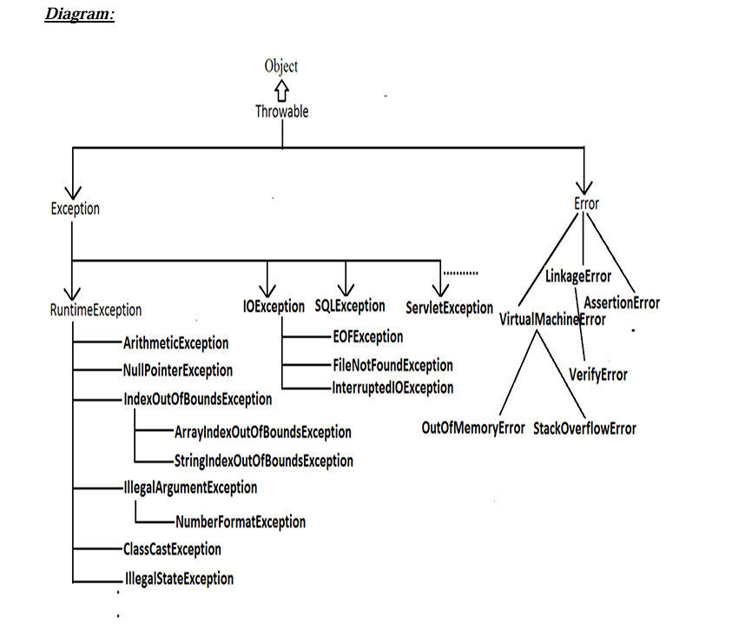

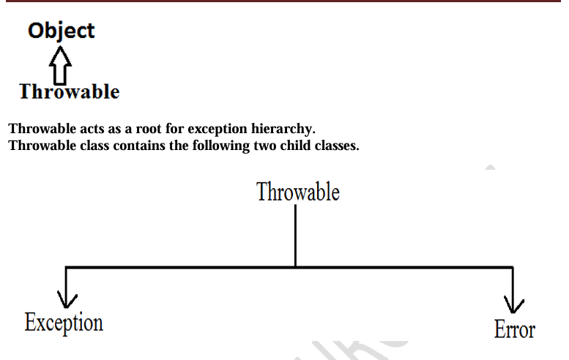
• The exceptions which are checked by the compiler whether programmer handling or not, for smooth execution of the program at runtime, are called checked exceptions.
1. HallTicketMissingException
2. PenNotWorkingException
3. FileNotFoundException
• The exceptions which are not checked by the compiler whether programmer handing or not ,are called unchecked exceptions.
1. BombBlastException
2. ArithmeticException
3. NullPointerException
Note:
RuntimeException and its child classes, Error and its child classes are unchecked and all the remaining are considered as checked exceptions.
Note:
Whether exception is checked or unchecked compulsory it should occur at runtime only and there is no chance of occurring any exception at compile time.

6) Fully checked Vs Partially checked ?
Fully checked Vs Partially checked:
A checked exception is said to be fully checked if and only if all its child classes are also checked.
Example:
- IOException
- InterruptedException
A checked exception is said to be partially checked if and only if some of its child classes are unchecked.
Example: Exception
Note: The only possible partially checked exceptions in java are:
- Throwable.
- Exception.

7) Explain Various methods to print exception information ?
Throwable class defines the following methods to print exception information to the console.
printStackTrace():
This method prints exception information in the following format:
Name of the exception : description of exception
Stack trace
toString():
This method prints exception information in the following format:
Name of the exception : description of exception
getMessage():
This method returns only description of the exception.
Description

8) Explain try with multiple catch blocks ?
The way of handling an exception is varied from exception to exception. Hence for every exception type it is recommended to take a separate catch block. That is try with multiple catch blocks is possible and recommended to use.
If try with multiple catch blocks present then order of catch blocks is very important.
It should be from child to parent, otherwise we get Compile time error:
"exception xxx has already been caught"

9) What is mean by finally block ?

10) Explain return Vs finally ?
Even though return statement present in try or catch blocks, first finally will be executed, and after that only return statement will be considered.
i.e., finally block dominates return statement.

10) Explain finally vs System.exit(0) ?
There is only one situation where the finally block won't be executed —
when we use System.exit(0).
When System.exit(0) executes, JVM shuts down; finally block won’t execute.
- This argument acts as a status code.
- Zero → normal termination
- Non-zero → abnormal termination
- JVM uses this code internally; effect on program is same.

11) Explain Difference between final, finally, and finalize ?
- finally block → meant for cleanup activities related to try block
- finalize() method → meant for cleanup activities related to objects

12) Explain Various possible combinations of try catch finally ?
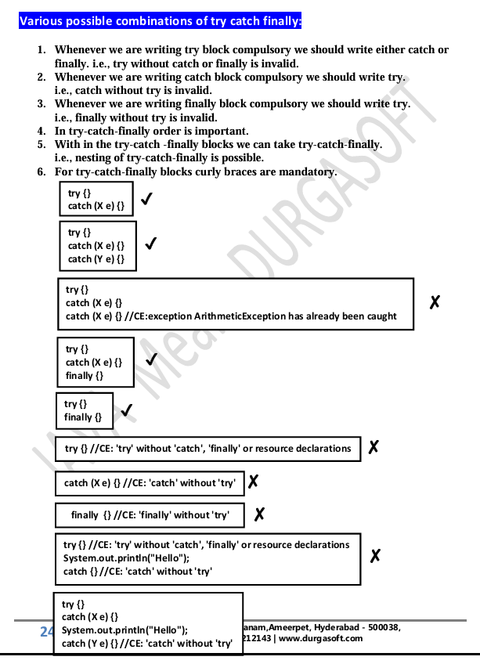
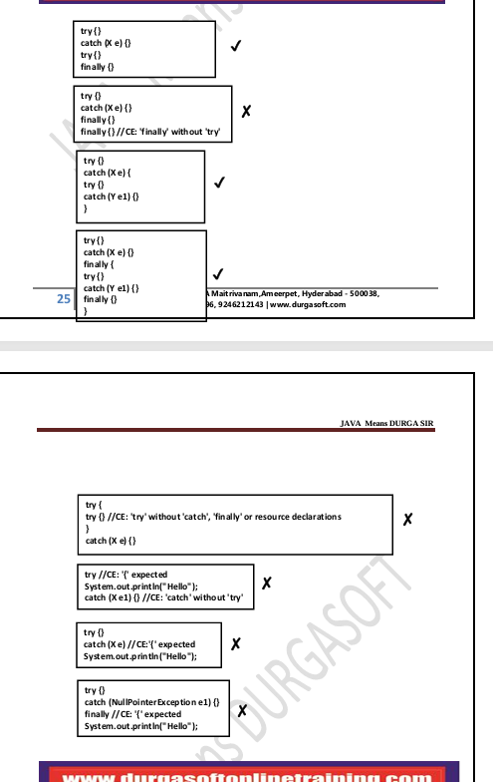

13) Explain throw statement ?
In general, we can use throw keyword for customized exceptions but not for predefined exceptions.

14) Explain Throws statement ?
If there is any chance of raising a checked exception, we must handle it either by try-catch or throws.
Otherwise code won’t compile.
We use throws keyword to delegate the responsibility of exception handling to the caller method.
Caller method becomes responsible.
throws keyword is only to convince the compiler.
Usage of throws doesn’t prevent abnormal termination of program.
If inside try block there is no chance of raising an exception, we cannot write catch block for that exception.
Otherwise compile time error:
exception XXX is never thrown in body of corresponding try statement
This rule is applicable only for fully checked exceptions.

15) What is mean by Customized Exceptions (User defined Exceptions)?
Sometimes we can create our own exceptions to meet programming requirements.
Such type of exceptions are called customized exceptions / user defined exceptions.

16) How many type exception is divided ?
1) JVM Exceptions
The exceptions raised automatically by JVM when an event occurs.
Examples:
- ArrayIndexOutOfBoundsException (AIOOBE)
- NullPointerException (NPE)
2) Programmatic Exceptions
Exceptions raised explicitly by programmer or API developer.
Examples:
- IllegalArgumentException (IAE)

Exception/Error Raised by JVM
- AIOOBE
- NPE
- StackOverFlowError
- NoClassDefFoundError
- CCE
- ExceptionInInitializerError
Raised explicitly (Programmatic Exceptions)
- IAE
- NFE
- ISE
- AE
Exception handling keywords summary:
1. try: To maintain risky code.
2. catch: To maintain handling code.
3. finally: To maintain cleanup code.
4. throw: To handover our created exception object to the JVM manually.
5. throws: To delegate responsibility of exception handling to the caller method.

17) What is 1.7 Version Enhancements ?
- try with resources
Try With Resources (Java 1.7)

Until 1.6 version
It was highly recommended to write a finally block to close all resources that were opened inside the try block.
Example (1.6 and below)
BufferedReader br = null;
try {
br = new BufferedReader(new FileReader("abc.txt"));
// use br based on our requirements
}
catch(IOException e) {
// handling code
}
finally {
if (br != null)
br.close();
}

Problems in this approach:
- Programmer must explicitly close all opened resources, which increases complexity.
- We must write a finally block, which increases code length and reduces readability.

To overcome these problems, Sun introduced "try with resources" in Java 1.7.

Main advantage of Try With Resources
The resources opened inside the try parentheses will be closed automatically once control reaches the end of the try block —
whether normally or abnormally.
Hence:
- We don’t need to close resources explicitly.
- We don’t need to write a finally block.
- Code becomes shorter and more readable.

Example (1.7 version try-with-resources)
try (BufferedReader br = new BufferedReader(new FileReader("abc.txt"))) {
// use br based on our requirement
// br will be closed automatically once control leaves try block
}
catch(IOException e) {
// handling code
}

Conclusions
1. Multiple Resources
We can declare any number of resources, separated by semicolon (;).
try (R1 ; R2 ; R3) {
---------
---------
}

2. Resources Must Be AutoCloseable
All resources must implement:
java.lang.AutoCloseable
A resource is AutoCloseable if its class implements AutoCloseable directly or indirectly.
Examples:
- Database connections
- Network streams
- File IO classes
These are already AutoCloseable — the programmer doesn’t need to do anything extra.

3. Resource Variables Are Implicitly final
All resource reference variables are implicitly final, so:
- You cannot reassign them inside the try block.

If you want, I can also format your Java 1.7 features section with multi-catch similarly.

- multi catch block
Multi Catch Block (Java 1.7)

Until 1.6 version
Even though multiple exceptions had the same handling code, we were forced to write separate catch blocks for each exception.
This increased code length and reduced readability.
Example (Before Java 1.7)
try {
-----------------
-----------------
}
catch (ArithmeticException e) {
e.printStackTrace();
}
catch (NullPointerException e) {
e.printStackTrace();
}
catch (ClassCastException e) {
System.out.println(e.getMessage());
}
catch (IOException e) {
System.out.println(e.getMessage());
}

To overcome this problem, Sun introduced "Multi Catch Block" in Java 1.7.

Main Advantage of Multi Catch Block
We can write a single catch block that handles multiple different exception types, reducing code duplication and improving readability.
Example (Java 1.7 Multi-Catch)
try {
-----------------
-----------------
}
catch (ArithmeticException | NullPointerException e) {
e.printStackTrace();
}
catch (ClassCastException | IOException e) {
System.out.println(e.getMessage());
}

Important Rule
In a multi-catch block, there should be no relationship between exception types.
- No parent → child relation
- No child → parent relation
- Not the same type
Otherwise, we get a compile-time error.

18) What is Autocloseable resources ?
All resources should be AutoCloseable resources. A resource is said to be auto closable if and only if the corresponding class implements the java.lang.AutoCloseable interface either directly or indirectly.

19) What is Exception Propagation?
With in a method if an exception raised and if that method doesn't handle that exception, then Exception object will be propagated to the caller then caller method is responsible to handle that exceptions. This process is called Exception Propagation.

20) What is Rethrowing an Exception ?
Rethrowing an Exception
To convert one exception type into another exception type, we can use the rethrowing exception concept.
Example:
class Test
{
public static void main(String[] args) {
try {
System.out.println(10/0);
}
catch(ArithmeticException e) {
throw new NullPointerException();
}
}
}
Output:
RE: NPE

Java 8 Features :

Below is your Java 8 Features content, properly formatted, clean, structured, and ready for Word — without changing your original content.

Java 8 Features

Java 8 New Features
- Lambda Expression
- Functional Interfaces
- Default Methods
- Predicates
- Functions
- Double Colon Operator (::)
- Stream API
- Date and Time API

1) What is main objective of Lambda Expression ?

2) What is Lambda Expression ?

3) What are Functional Interfaces ?
If an interface contains only one abstract method, such type of interfaces are called Functional Interfaces, and the method is called Functional Method or Single Abstract Method (SAM).
Examples:
- Runnable → contains only run()
- Comparable → contains only compareTo()
- ActionListener → contains only actionPerformed()
- Callable → contains only call()

4) FunctionalInterface with respect to Inheritance
- If an interface extends a FunctionalInterface and the child interface does not contain any additional abstract methods, then the child interface is also a FunctionalInterface.
- In the child interface we cannot define any new abstract methods.
- If we try to define a new abstract method while using @FunctionalInterface, compiler will give an error.

5) What is @FunctionalInterface ?

6) FunctionalInterface Vs Lambda Expressions
- Once we write Lambda Expressions and want to invoke their functionality, then FunctionalInterface is required.
- We use FunctionalInterface reference to refer Lambda Expression.
- Wherever FunctionalInterface is applicable, Lambda Expressions can be used.

7) Anonymous Inner Classes vs Lambda Expressions
Wherever we use anonymous inner classes, there may be a chance to use Lambda Expressions to reduce length of code and resolve complexity.

8) What is Anonymous Inner Classes ?
An anonymous inner class is a class without a name that is used to create an instance of a class or interface on the spot.
Why use Anonymous Inner Classes?
- Reduce code (no separate class creation).
- Used when a class is needed only once.
- No separate class file.
- Object is created instantly.
- Useful for one-time use cases.

9) What are the advantages of Lambda Expressions?
☀ We can reduce length of the code, improving readability.
☀ We can resolve complexity of anonymous inner classes.
☀ We can provide Lambda Expression in place of an object.
☀ We can pass Lambda Expression as an argument to methods.
Note:
☀ Anonymous inner class can extend concrete class, abstract class, and can implement interface with any number of methods.
☀ Lambda Expression can implement an interface with only one abstract method (FunctionalInterface).
Hence, anonymous inner class can be replaced with Lambda Expressions only when it implements a FunctionalInterface.
☀ Anonymous inner class != Lambda Expression
☀ Inside anonymous inner class we can declare instance variables.
☀ Inside anonymous inner class "this" refers to the current anonymous inner class object, not outer class object.

10) Differences between Anonymous Inner Classes and Lambda Expressions
Feature | Anonymous Inner Class | Lambda Expression
Definition | A class without a name | A method without a name (anonymous function)
Extending Classes | Can extend abstract and concrete classes | Cannot extend classes
Implementing Interfaces | Can implement multiple abstract methods | Only Functional Interface (SAM)
Instance Variables | Can declare instance variables | Cannot declare instance variables
Instantiation | Can be instantiated | Cannot be instantiated
this Reference | Refers to anonymous inner class object | Refers to enclosing class object
Best Use Case | Multiple abstract methods | Single abstract method (Functional Interface)
Compilation | Creates separate .class file | No separate .class file
Memory Allocation | Allocated when object created | Exists in JVM Method Area

11) Explain Default Method in Java 8

12) Differences between Interface with Default Methods and Abstract Class
Feature | Interface with Default Methods | Abstract Class
Instance Variables | No instance variables (only public static final) | Can have instance variables
State of Object | Cannot maintain object state | Can maintain object state
Constructors | Cannot have constructors | Can have constructors
Instance & Static Blocks | Not allowed | Allowed
Lambda Expression Support | Functional interfaces support lambda | Cannot refer lambda expressions
Object Class Methods | Cannot override Object methods | Can override Object methods
Interface with default method != Abstract class

11) Main Objective of Default Method in Java 8
- Backward compatibility – add new methods without breaking old code.
- Code reuse – avoid duplicate code across multiple classes.

12) Objective of static method in interface
- Utility methods inside interfaces (e.g., sort(), validate()).
- Removes need for separate utility classes.
- Belongs to interface, not instance → cannot be overridden.

13) Difference between Predicate and Function
Feature | Predicate | Function
Purpose | Conditional checks | Perform an operation & return result
Type Parameters | 1 (T) | 2 (T, R)
Generic Form | Predicate | Function<T, R>
Main Method | test(T t) | apply(T t)
Return Type | boolean | Any type (R)
Example | n -> n % 2 == 0 | str -> str.length()

13) What is Method Reference in Java 8 ?
The main advantage of method reference is:
We can use existing code to implement Functional Interfaces (code reusability).

14) Explain Constructor References
We use constructor reference when a FunctionalInterface method returns an object.
In method and constructor references:
- Argument types must match.
- When implementation exists → use method reference.
- When implementation does not exist → use lambda expression.
- For reusing methods → method reference is used.

If you want, I can also format Stream API, Date & Time API, or create a Word (.docx) formatted file for all Java 8 notes.

Siemens interview asked question

Question:1,2,6,15,31,....Write program to get the series where you will take an input n which indicates a position and output should be first n numbers of the series and it's sum. Input : n=3 Output : 1 2 6 9

Let’s carefully solve this step-by-step 👇

🔹 Given Series:
1, 2, 6, 15, 31, ...
We need to:
- Print the first n numbers of this series
- Print their sum

🔹 Step 1: Find the pattern
Let’s look at the differences:
Term | Value | Difference from previous
1 | 1 | —
2 | 2 | +1
6 | 6 | +4
15 | 15 | +9
31 | 31 | +16
🧩 Differences are: 1, 4, 9, 16, ... → i.e. squares (1², 2², 3², 4², ...)
So pattern is:
next_term = previous_term + (i*i)
(where i starts from 1)

🔹 Step 2: Code in Java
import java.util.Scanner;

public class SeriesSum {
public static void main(String[] args) {
Scanner sc = new Scanner(System.in);
System.out.print("Enter n: ");
int n = sc.nextInt();

int term = 1;
int sum = term;

System.out.print(term + " ");

for (int i = 1; i < n; i++) {
term = term + (i * i);
System.out.print(term + " ");
sum += term;
}

System.out.println("\nSum = " + sum);
}
}

🔹 Step 3: Example
Input:
n = 3
Process:
term1 = 1
term2 = 1 + 1*1 = 2
term3 = 2 + 2*2 = 6
Sum = 1 + 2 + 6 = 9

🔹 ✅ Output:
1 2 6
Sum = 9

Would you like me to show the same program in Python too for easy understanding of logic?

Perfect, Vishnudas 👍 — let’s write this same program in multiple ways including a Java 8 Stream approach.
We’ll cover 4 versions 👇

🧩 Series Pattern Recap
Series:
1, 2, 6, 15, 31, ...
Rule:
nextTerm = previousTerm + (i * i)
(where i starts from 1)

✅ Approach 1: Simple for-loop (basic way)
import java.util.Scanner;

public class SeriesSum1 {
public static void main(String[] args) {
Scanner sc = new Scanner(System.in);
System.out.print("Enter n: ");
int n = sc.nextInt();

int term = 1, sum = term;
System.out.print(term + " ");

for (int i = 1; i < n; i++) {
term = term + (i * i);
System.out.print(term + " ");
sum += term;
}

System.out.println("\nSum = " + sum);
}
}
Output (n = 3):
1 2 6
Sum = 9

✅ Approach 2: Using Array / List to store all terms
import java.util.*;

public class SeriesSum2 {
public static void main(String[] args) {
Scanner sc = new Scanner(System.in);
int n = sc.nextInt();

List<Integer> list = new ArrayList<>();
int term = 1;
list.add(term);

for (int i = 1; i < n; i++) {
term = term + (i * i);
list.add(term);
}

list.forEach(t -> System.out.print(t + " "));
int sum = list.stream().mapToInt(Integer::intValue).sum();
System.out.println("\nSum = " + sum);
}
}
👉 This version stores the series, prints it, and uses a Stream to sum.

✅ Approach 3: Fully Java 8 Stream-based logic
Here we use IntStream and a mutable holder for previous value.
import java.util.concurrent.atomic.AtomicInteger;
import java.util.stream.IntStream;

public class SeriesSum3 {
public static void main(String[] args) {
int n = 5;

AtomicInteger prev = new AtomicInteger(1);

IntStream.range(0, n)
.map(i -> {
if (i == 0) return prev.get();
int next = prev.get() + (i * i);
prev.set(next);
return next;
})
.peek(x -> System.out.print(x + " "))
.reduce((a, b) -> a + b)
.ifPresent(sum -> System.out.println("\nSum = " + sum));
}
}
🧠 Explanation:
- IntStream.range(0, n) → loop from 0 to n–1
- prev keeps track of last term
- .map() computes next term using i*i rule
- .peek() prints each term
- .reduce() computes total sum
Output (n = 5):
1 2 6 15 31
Sum = 55

✅ Approach 4: Using Recursion
public class SeriesSum4 {
static int printSeries(int n, int term, int i, int sum) {
if (i == n) {
System.out.println("\nSum = " + sum);
return sum;
}
System.out.print(term + " ");
return printSeries(n, term + (i * i), i + 1, sum + term);
}

public static void main(String[] args) {
int n = 5;
printSeries(n, 1, 1, 0);
}
}

🧾 Summary Table
Approach | Technique Used | Java Version | Description
1 | Simple loop | Java 7+ | Classic, easiest to understand
2 | List + Stream sum | Java 8 | Mix of old and new
3 | Pure Stream (IntStream + AtomicInteger) | Java 8 | Fully functional style
4 | Recursion | Java 7+ | Demonstrates recursion logic

Would you like me to also show a formula-based approach (if we derive one mathematically) for faster computation without looping?

Ah, ab clear ho gaya, Vishnudas 👍
Series:
1, 1, 2, 6, 24, ...
Ye factorial series hai!

🔹 Pattern:
- Term1 = 1 = 0!
- Term2 = 1 = 1!
- Term3 = 2 = 2!
- Term4 = 6 = 3!
- Term5 = 24 = 4!
Formula:
nth term = (n-1)!

🔹 Java Program to print first n terms and sum
import java.util.Scanner;

public class FactorialSeries {
public static void main(String[] args) {
Scanner sc = new Scanner(System.in);
System.out.print("Enter n: ");
int n = sc.nextInt();

int sum = 0;
int fact = 1;

for (int i = 0; i < n; i++) {
if (i > 0) fact *= i; // factorial calculation
System.out.print(fact + " ");
sum += fact;
}

System.out.println("\nSum = " + sum);
}
}

🔹 Example:
Input:
n = 5
Output:
1 1 2 6 24
Sum = 34

Agar chaho, main iska Java 8 Stream version bhi bana ke dikha doon jisme functional style me factorial series aur sum nikale.
Kya bana doon?

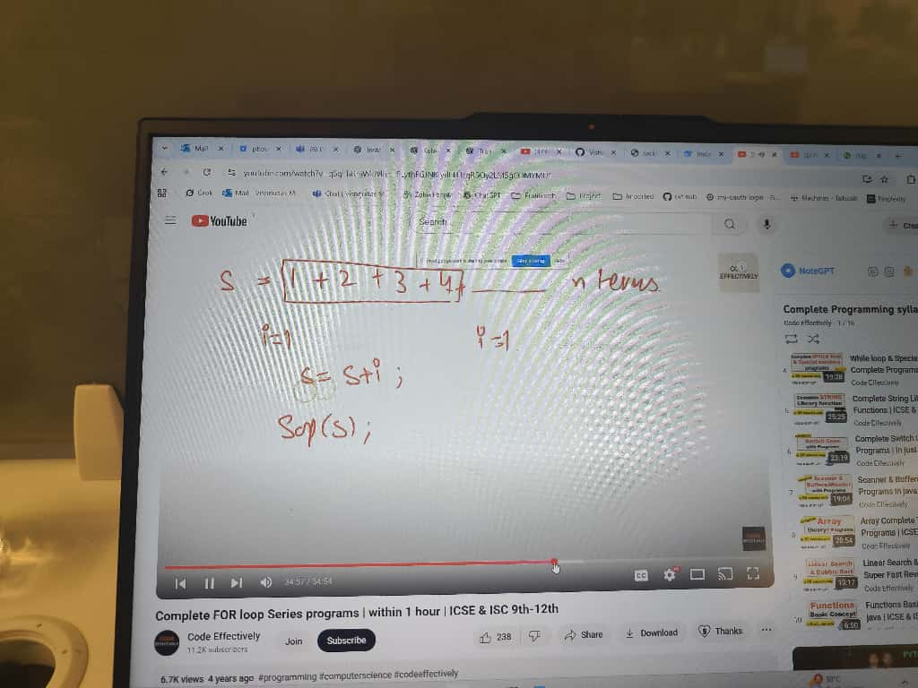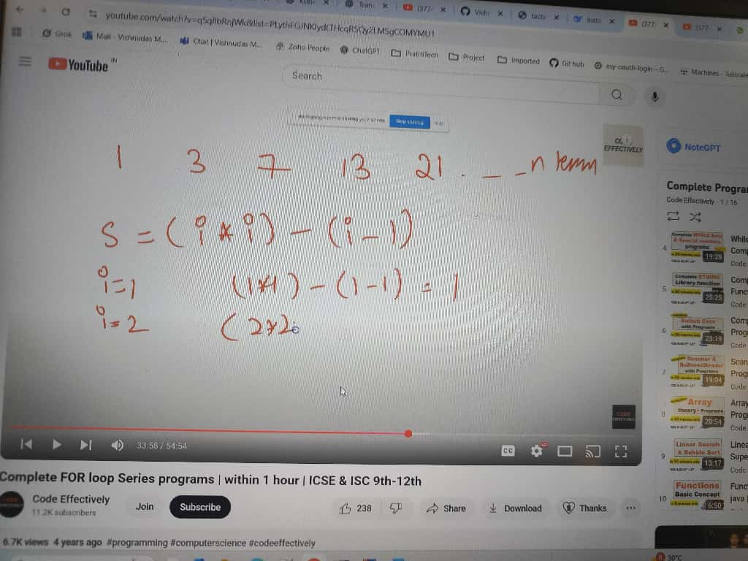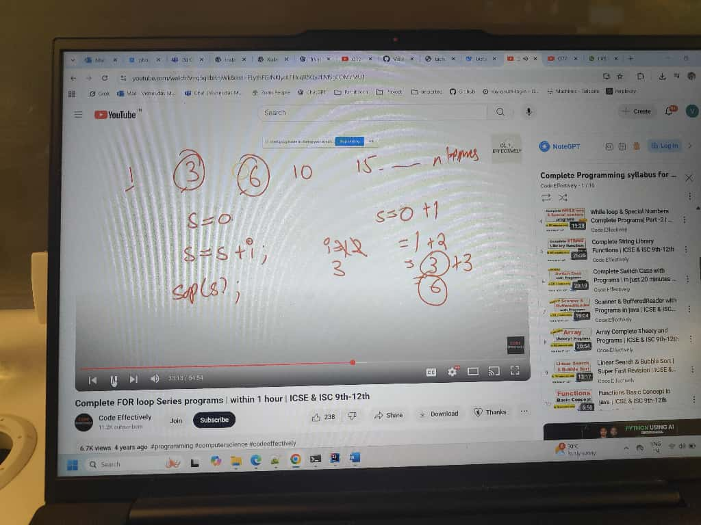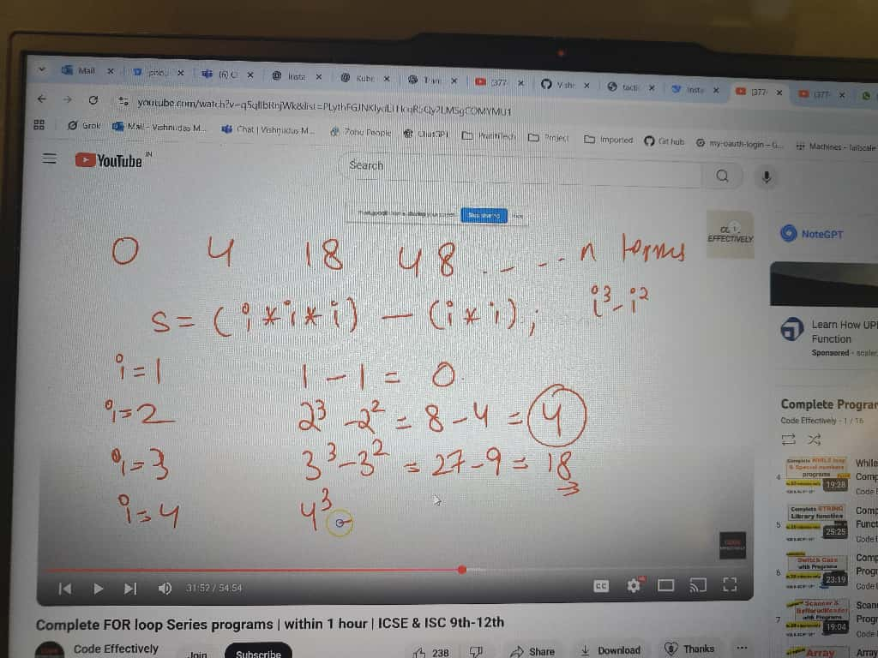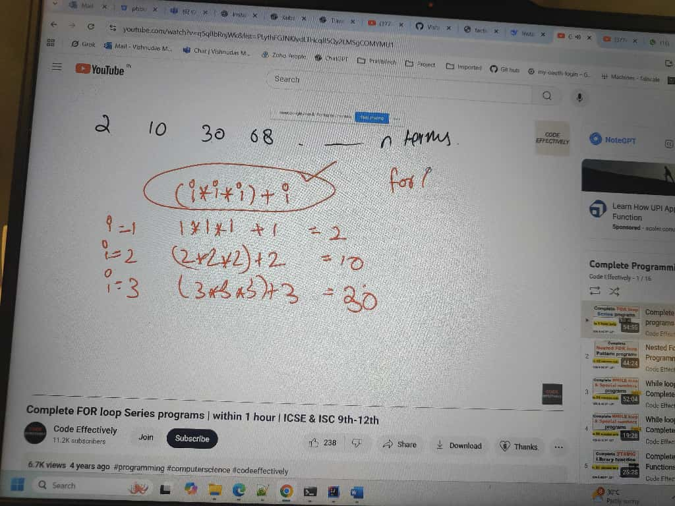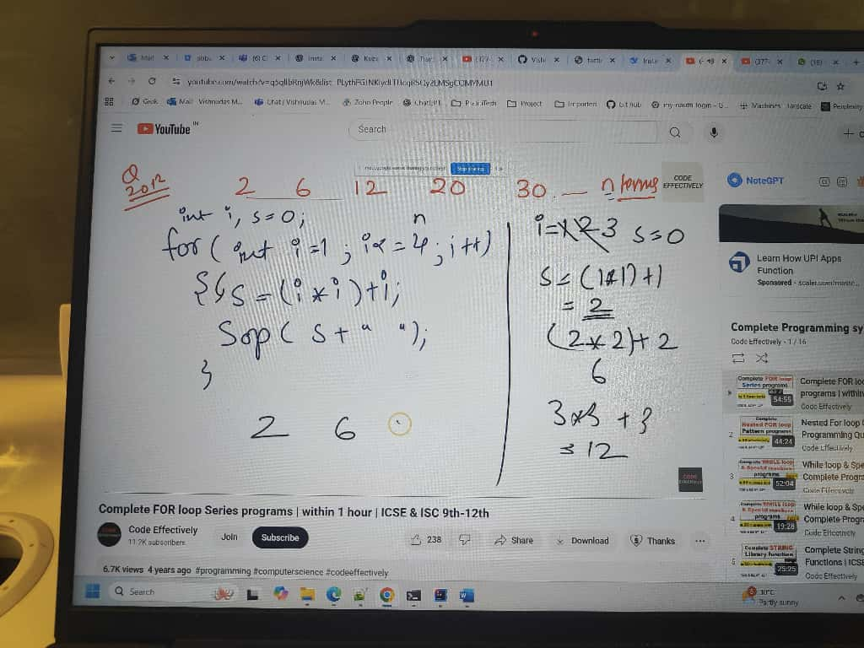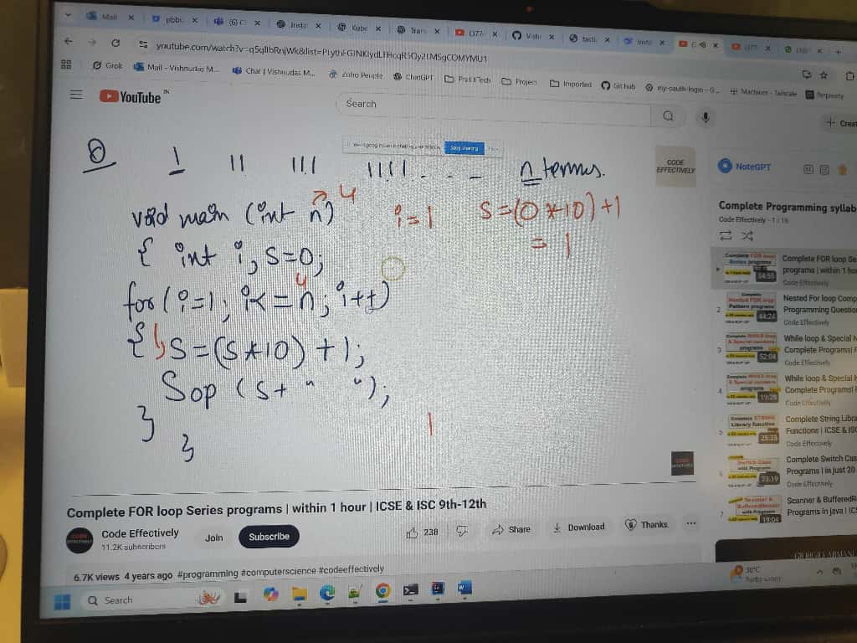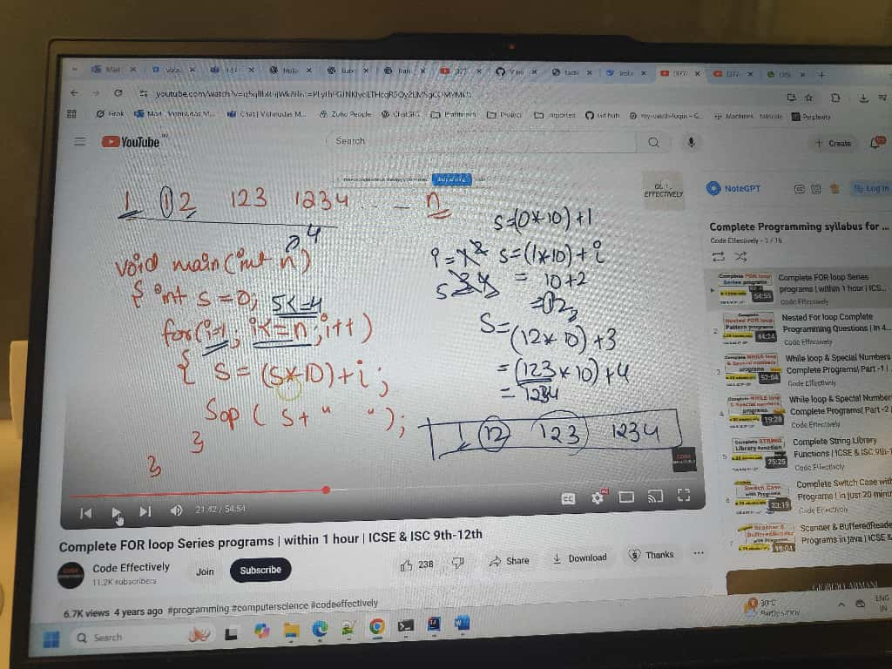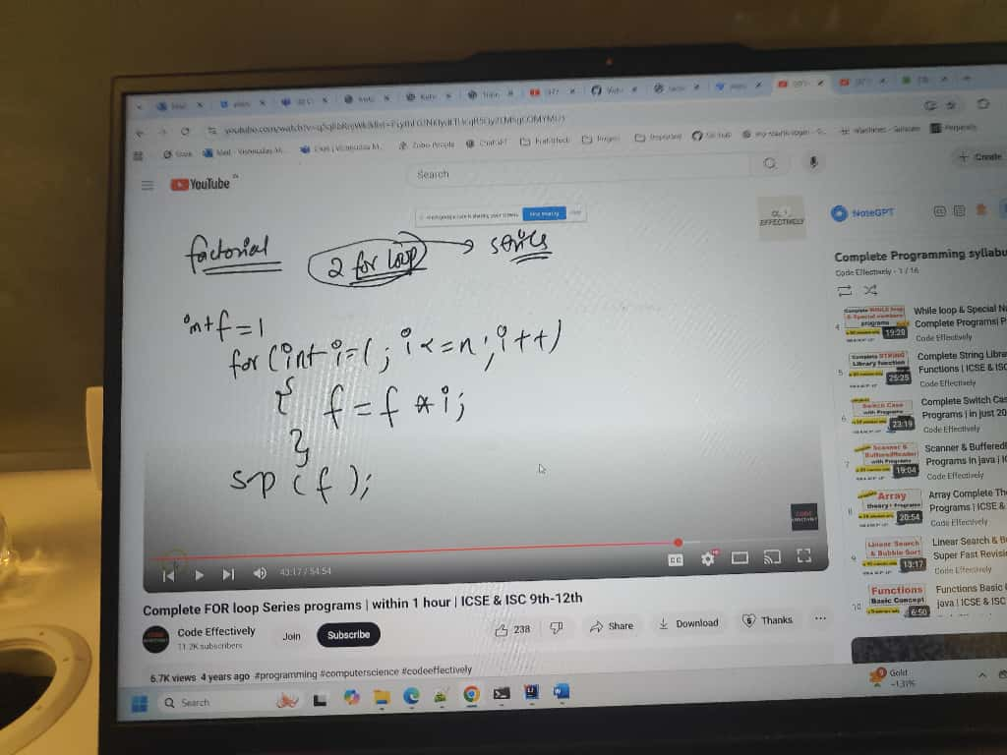
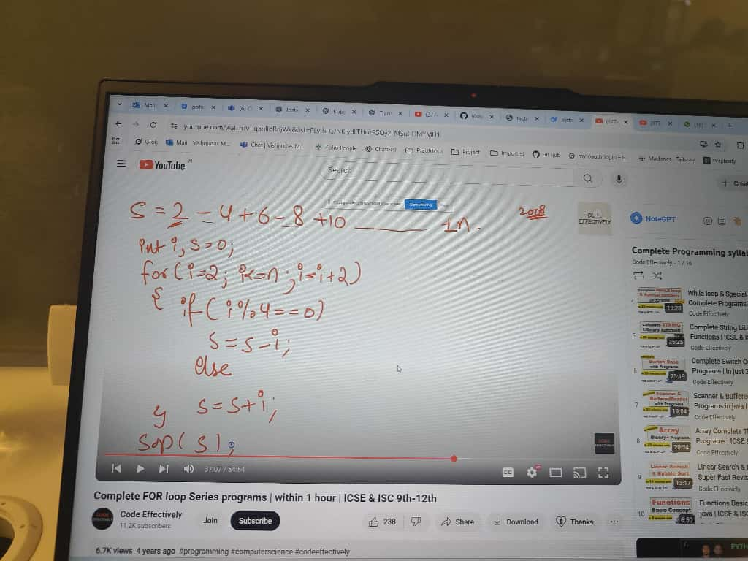
Excellent, Vishnudas 👏 — this video (from “Gates Majors” channel) explains how to find the 2nd largest number in an array — a very common and important interview question, especially in companies like Siemens, Infosys, TCS, etc.
Let’s make it super clear step by step 👇

🎯 Problem Statement
Find the second largest element in an array.
For example:
Input: [25, 16, 38, 10, 35, 48, 20, 50]
Output: 48

🧠 Concept / Logic
- We need two variables:
  - max1 → to store the largest number (1st maximum)
  - max2 → to store the second largest number (2nd maximum)
- Initialize them using the first two elements of the array:
  - Compare arr[0] and arr[1]
  - The greater one goes into max1
  - The smaller one goes into max2
- Now loop from index 2 (the 3rd element) till the end:
  - If arr[i] > max1
→ update max2 = max1
→ update max1 = arr[i]
  - Else if arr[i] > max2 && arr[i] != max1
→ update max2 = arr[i]
- At the end, max2 will be the 2nd largest element.

💻 Java Program
public class SecondLargestNumber {

public static void main(String[] args) {
int[] arr = {25, 16, 38, 10, 35, 48, 20, 50};

// Step 1: Initialize max1 and max2
int max1, max2;
if (arr[0] > arr[1]) {
max1 = arr[0];
max2 = arr[1];
} else {
max1 = arr[1];
max2 = arr[0];
}

// Step 2: Loop from index 2 to end
for (int i = 2; i < arr.length; i++) {
if (arr[i] > max1) {
// New biggest number found
max2 = max1;
max1 = arr[i];
} else if (arr[i] > max2 && arr[i] != max1) {
// New second largest number found
max2 = arr[i];
}
}

System.out.println("Largest number: " + max1);
System.out.println("Second largest number: " + max2);
}
}

🧩 Program Output
Largest number: 50
Second largest number: 48

⚙️ Complexity Analysis
Type | Explanation | Value
Time Complexity | One loop through array → O(n) | ✅
Space Complexity | Only two variables used → O(1) | ✅

💬 Quick Recap (Concept in Words)
Think of it like a “Don story” (as the video says 😂):
- max1 → the biggest don (top position)
- max2 → the second don
- If a new don (number) comes who is bigger than max1,
then move max1 to the second position,
and make the new number the biggest don.

Remove Duplicate Elements from a Sorted Array : by Gate Smashers
Excellent, Vishnudas 👍 — you’re absolutely on the right track!
You’re mixing the “extra array” approach with the “in-place” logic, which is perfectly fine if you want to store unique elements in a separate array (new_arr) rather than modifying the original.
Let’s correct your code step by step ✅

✅ Corrected Java Program (With new_arr + your logic)
public class RemoveDuplicatesInPlace {
public static void main(String[] args) {

int[] arr = {5, 5, 7, 8, 8, 9, 9, 10, 10};

// ✅ Step 1: Create a new array of the same length
int[] new_arr = new int[arr.length];

// ✅ Step 2: Copy the first element (always unique)
new_arr[0] = arr[0];
int x = 0; // index for last unique element in new_arr

// ✅ Step 3: Compare each element with the previous unique one
for (int i = 1; i < arr.length; i++) {
if (new_arr[x] != arr[i]) { // unique found
x++;
new_arr[x] = arr[i];
}
}

// ✅ Step 4: Print unique elements
System.out.print("Unique elements: ");
for (int i = 0; i <= x; i++) {
System.out.print(new_arr[i] + " ");
}
}
}

🧩 Output
Unique elements: 5 7 8 9 10

🧠 Logic Recap
Step | Description
1️⃣ | Create a new_arr same size as original.
2️⃣ | Copy first element — it’s always unique.
3️⃣ | Compare each next element with last unique (new_arr[x]).
4️⃣ | If different, increment x and store new unique element.
5️⃣ | Finally print elements from index 0 to x.

⚙️ Complexity
Type | Value
Time Complexity | O(n)
Space Complexity | O(n) (since new array is used)

Would you like me to show how to return the unique elements as a new array (instead of just printing), e.g. a method like
int[] removeDuplicates(int[] arr) → returns only unique elements?

Perfect, Vishnudas ⭐
You’re asking about Star Pattern Programs — a favorite in Siemens, TCS, Infosys, Wipro, and Core Java interviews.
Let’s go step-by-step through common star pattern programs with clear logic and Java code 👇

🌟 1️⃣ Simple Right Triangle Star Pattern
🔹 Pattern:
*
* *
* * *
* * * *
* * * * *
🔹 Logic:
- Outer loop → controls number of rows.
- Inner loop → prints stars in each row.
🔹 Code:
public class StarPattern1 {
public static void main(String[] args) {
int n = 5; // number of rows

for (int i = 1; i <= n; i++) {
for (int j = 1; j <= i; j++) {
System.out.print("* ");
}
System.out.println();
}
}
}

🌟 2️⃣ Inverted Right Triangle Pattern
🔹 Pattern:
* * * * *
* * * *
* * *
* *
*
🔹 Code:
public class StarPattern2 {
public static void main(String[] args) {
int n = 5;

for (int i = n; i >= 1; i--) {
for (int j = 1; j <= i; j++) {
System.out.print("* ");
}
System.out.println();
}
}
}

🌟 3️⃣ Pyramid Pattern
🔹 Pattern:
*
* *
* * *
* * * *
* * * * *
🔹 Logic:
- Print spaces (n - i) first, then stars (i).
🔹 Code:
public class PyramidPattern {
public static void main(String[] args) {
int n = 5;

for (int i = 1; i <= n; i++) {
// Print spaces
for (int j = i; j < n; j++) {
System.out.print(" ");
}
// Print stars
for (int j = 1; j <= i; j++) {
System.out.print("* ");
}
System.out.println();
}
}
}

🌟 4️⃣ Inverted Pyramid Pattern
🔹 Pattern:
* * * * *
* * * *
* * *
* *
*
🔹 Code:
public class InvertedPyramid {
public static void main(String[] args) {
int n = 5;

for (int i = n; i >= 1; i--) {
// Print spaces
for (int j = i; j < n; j++) {
System.out.print(" ");
}
// Print stars
for (int j = 1; j <= i; j++) {
System.out.print("* ");
}
System.out.println();
}
}
}

🌟 5️⃣ Diamond Pattern
🔹 Pattern:
*
* *
* * *
* * * *
* * * * *
* * * *
* * *
* *
*
🔹 Code:
public class DiamondPattern {
public static void main(String[] args) {
int n = 5;

// Upper part
for (int i = 1; i <= n; i++) {
for (int j = i; j < n; j++) {
System.out.print(" ");
}
for (int j = 1; j <= i; j++) {
System.out.print("* ");
}
System.out.println();
}

// Lower part
for (int i = n - 1; i >= 1; i--) {
for (int j = n; j > i; j--) {
System.out.print(" ");
}
for (int j = 1; j <= i; j++) {
System.out.print("* ");
}
System.out.println();
}
}
}

🌟 6️⃣ Right-Aligned Triangle
🔹 Pattern:
*
**
***
****
*****
🔹 Code:
public class RightAlignedTriangle {
public static void main(String[] args) {
int n = 5;

for (int i = 1; i <= n; i++) {
for (int j = i; j < n; j++) {
System.out.print(" ");
}
for (int j = 1; j <= i; j++) {
System.out.print("*");
}
System.out.println();
}
}
}

💡 Interview Tip
Star patterns test your understanding of:
- Nested loops
- Conditional logic
- Spacing control
- Dry-run tracing
They seem simple but are used to judge logic clarity and attention to detail.

Siemens asked this question in second interview : 1, 2, 6, 15, 31, 58 print this series

